BLOOD GLUCOSE RECORD
DURING RAMADAN

Name: __________________________ Diabetes Doctor in charge: _____________________________
IC No: ___________________________ Diabetes Educator: ___________________________________
Contact No: ______________________
Diabetes Treatment for Sahur (pre-dawn meal) | Diabetes Treatment for Iftar (break fast meal)

Date | Before  Sahur  (pre-dawn meal) | 12 Noon | Before  Iftar  (break fast meal) | 3 Hours  After Iftar | Remarks

Report blood glucose readings every ________________________, via
E-mail: ___________________________________________________________
Voicemail: _____________________

Managing diabetes is a life-long journey. Let us support your journey towards better health.  For more information on resources for people living with diabetes, please scan the following QR code: | 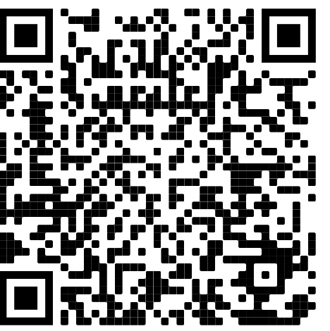

Date | Before  Sahur  (pre-dawn meal) | 12 Noon | Before  Iftar  (break fast meal) | 3 Hours  After Iftar | Remarks

